Visual Text Study – Gattaca
Close Analysis of Opening Scene

Image from Film | Visual Language | Explanation
 | - Extreme close-up of magnified microscopic hairs, fingernails, and skin  - Special Effect - bigitures  - Artificial blue lighting  - Slow paced music  - Sound effects of hairs crashing to the ground | The opening credits emphasis the significance of the seemingly insignificant loss of hairs, fingernails, and skin flakes. The extreme close-up of the bigitures (big minitures) of hair with the added sound of them crashing to the ground alerts the audience to the importance of these…
 | - Extreme close-up of Vincent shaving  - Magnified sound of his razor scraping against his face  - Fill lighting creating shadow on Vincent’s face  - Artificial blue lighting  - Slow paced music | The scene fades out and then fades in with an extreme close-up of Vincent shaving. The exaggerated sound of scraping emphasises how meticulously Vincent treats this mundane, everyday task. The importance of this ‘ritual’ is shown throughout the film as hair, nails and skin contain DNA which would expose Vincent’s false identity.
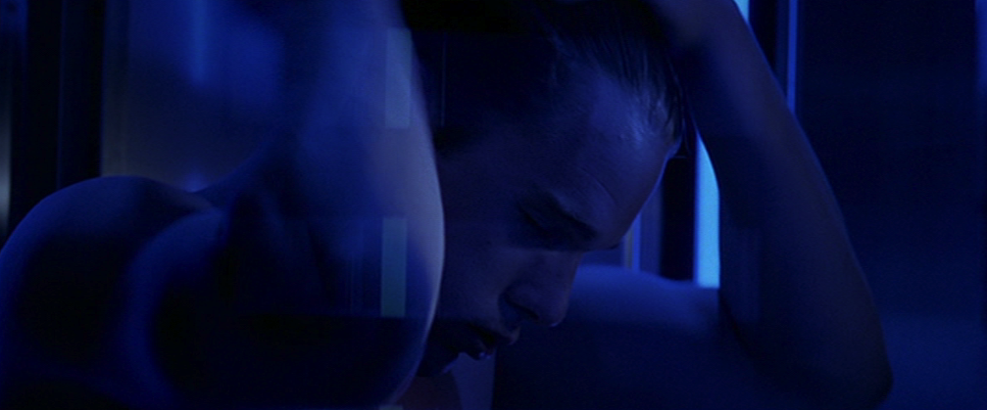 | - Close-up of Vincent brushing his hair  - Magnified sound of brush scraping his scalp  - Under-exposed lighting creating darkness and shadow  - Artificial blue lighting  - Slow paced music | Vincent’s daily routine continues as he painstakingly brushes his hair and scours his skin before showering…
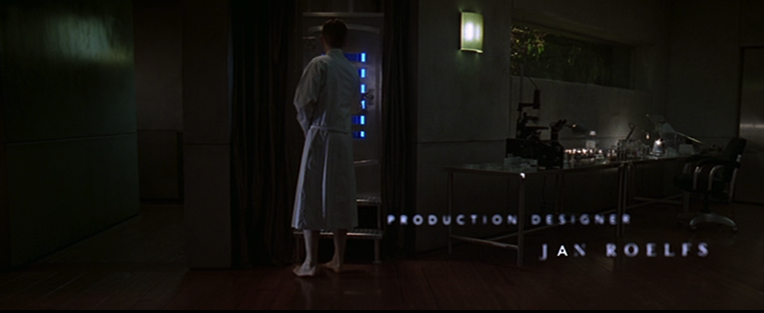 | - Wide-shot showing Vincent’s apartment and sanitation chamber  - Normal indoor lighting of the lamps in his apartment  - Vincent dressed in a dressing-gown  - Fire inside sanitation chamber as he destroys any ‘evidence’
