Visual Text Study – Gattaca
Close Analysis of Swimming Scene

Image from Film | Visual / Audio Language | Explanation
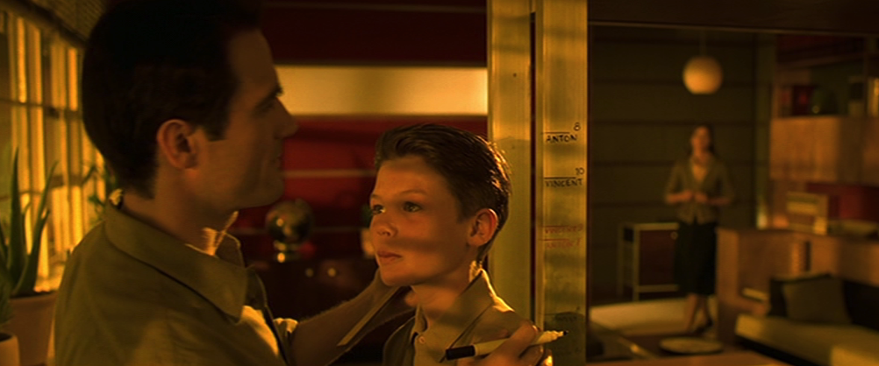 | - Low angled double-shot of Anton and Antonio (Vincent’s brother and father) to make Anton look big and powerful – The Chosen One… They then embrace and hug  - Bright, natural lighting streaming in on Anton’s face  - Voiceover: ‘A son my father thought worthy of his name’
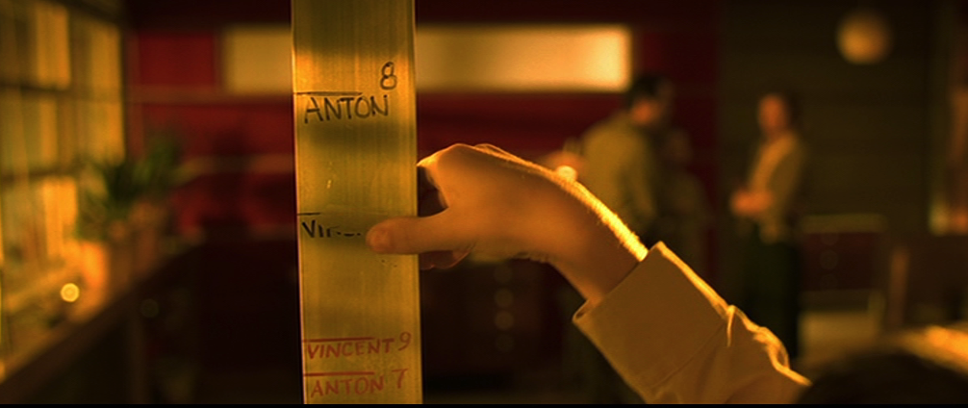 | - Close-up of ‘Height Chart’ showing that Anton (aged 8) is much taller than Vincent (aged 10)  - Vincent rubs out his own height line – angry, frustrated, disappointed by his own lack of height  - Instrumental music – slow paced
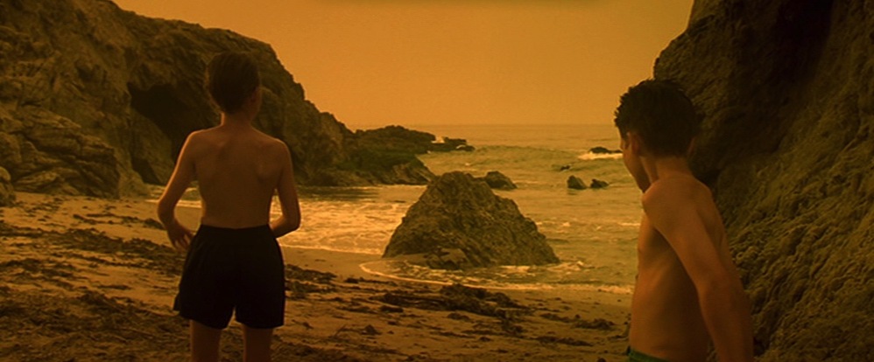 | - Cuts to mid-shot of Anton and Vincent by the ocean  - Sound of waves crashing on the shore  - Voiceover: ‘By the time we were playing at Blood Brothers, I understood that there was something entirely different flowing through my veins…’
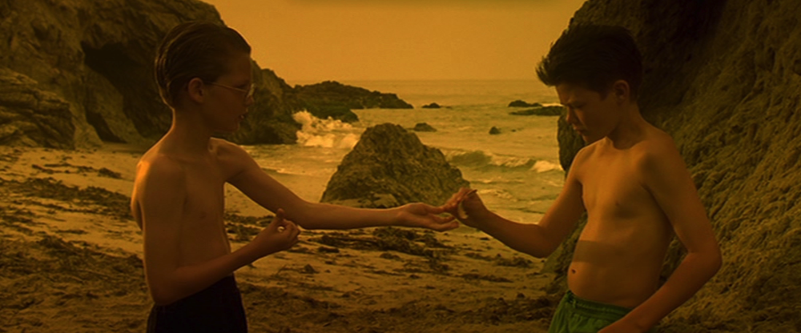 | - Zooms into close-up of the brothers cutting their thumbs to be ‘Blood Brothers’ – Anton refuses to  - Voiceover continued: ‘… and I’d need an awful lot more than a drop if I was going to get anywhere.’  - Music withdrawn momentarily
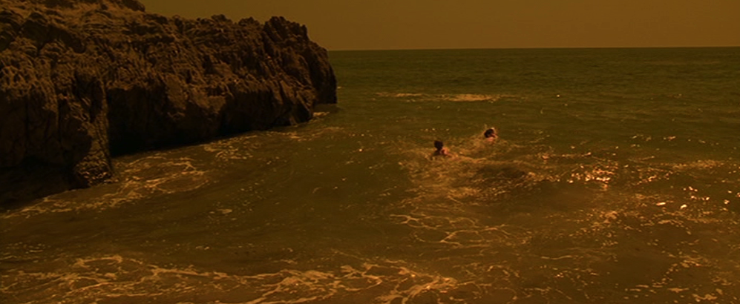 | - Long-shot of brothers swimming out to sea  - Voiceover: ‘Our favourite game was Chicken. When our parents weren’t watching we used to swim out as far as we dared…’  - Instrumental music reintroduced
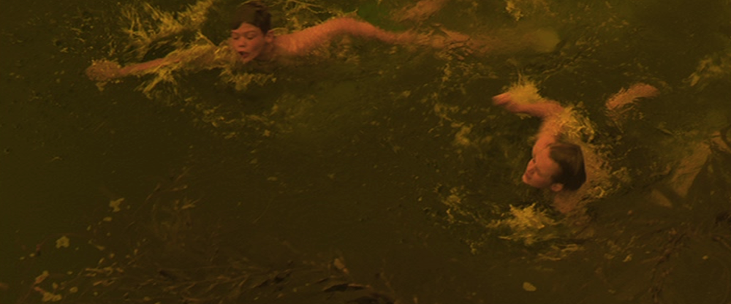 | - Over-head shot of two brother swimming out to sea further – Vincent’s strokes are looking weak and tired; Anton still going strong  - Voiceover continued: ‘It was about who would get scared and turn back first…’  - Sound of heavy splashing strokes
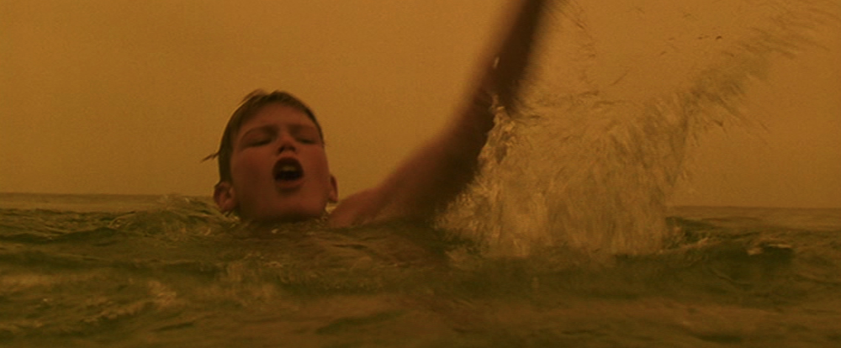 | - Mid-shot of Anton far ahead of Vincent  - Lighting using sepia coloured filter to emphasise that it is a memory / flashback  - Dialogue: ‘Come on you coward’
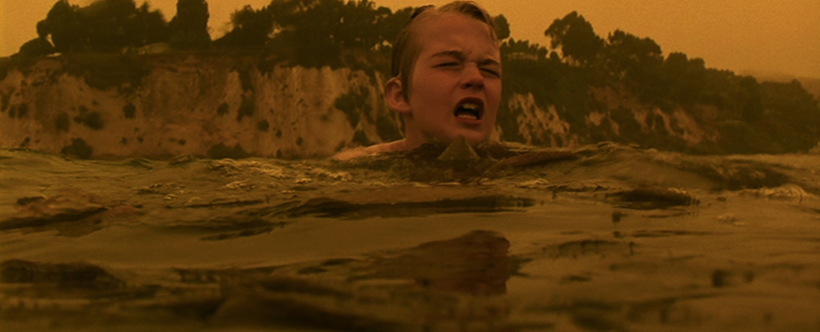 | - Cuts to mid-shot of Vincent who is in trouble – too tired to continue swimming with a pained expression on his face  - Voiceover continued: ‘Of course, it was always me.’
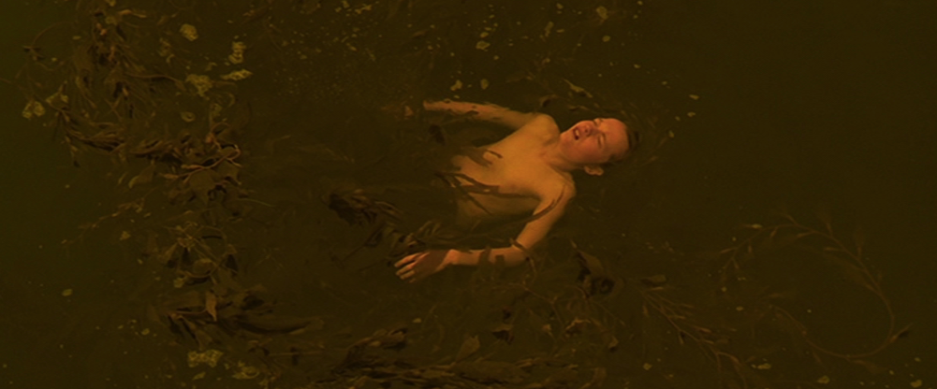 | - Over-head shot of Vincent floating on his back – expresses his disappointment and feelings of failure  - Voiceover continued: ‘Anton was by far the stronger swimmer; he had no excuse to fail.’
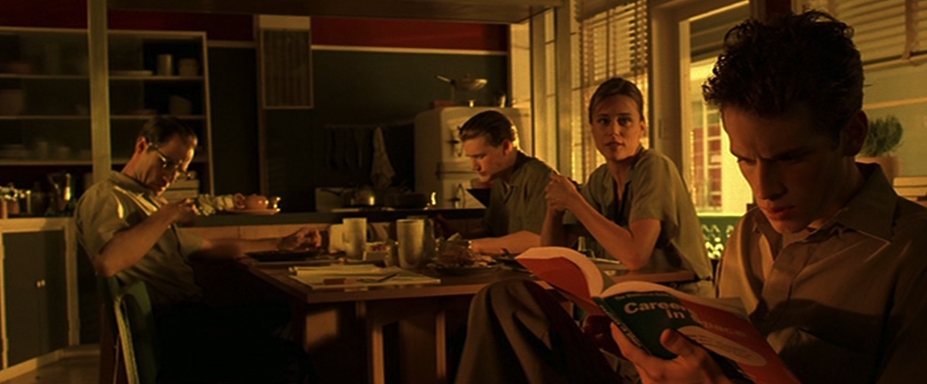 | - Cuts and flashforward to family sitting round the dinner table  - Vincent at the foreground and off-centre of shot to show how he is physically and emotionally distanced from his family – doesn’t fit in and studying  - Fill light creating shadow on his face
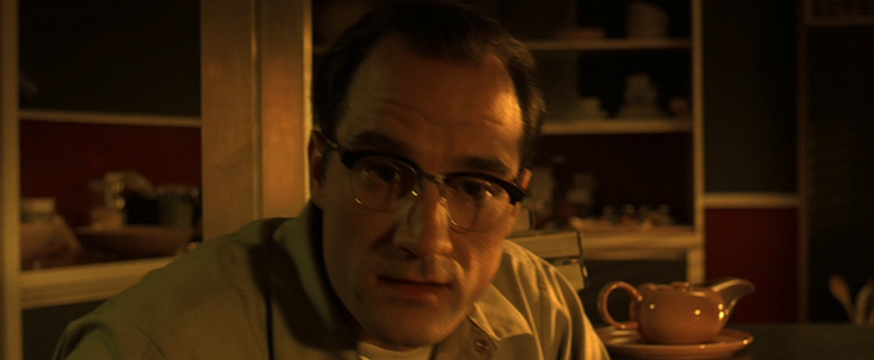 | - Cuts to close-up of his father’s face  - Fill light from the side creating shadow on the face as he delivers ‘bad news’ to Vincent  - Dialogue: ‘The only way you’ll see the inside of a spaceship is if you’re cleaning it…’
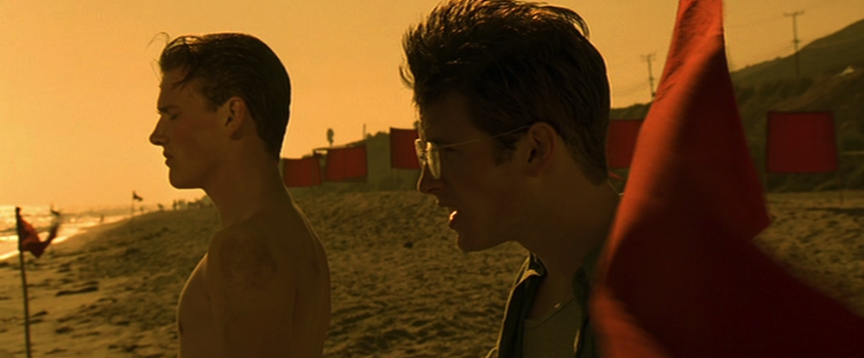 | - Cuts to show flashforward – now the boys are ready to swim again as adolescents  - Bright lighting to suggest hope  - Dialogue: ‘You sure you want to do this? You know you’re gonna lose…’ – Anton to Vincent  - Sound of wind blowing the flags
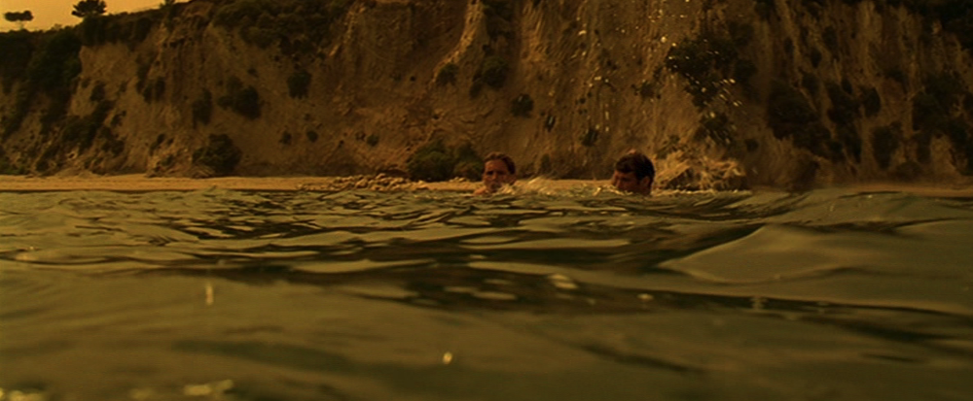 | - Mid-shot of boys entering the water echoes earlier shot, but camera is reversed (now in front of them instead of behind) to foretell a different outcome  - Voiceover: ‘It was the last time we swam together…’  - Instrumental music reintroduced
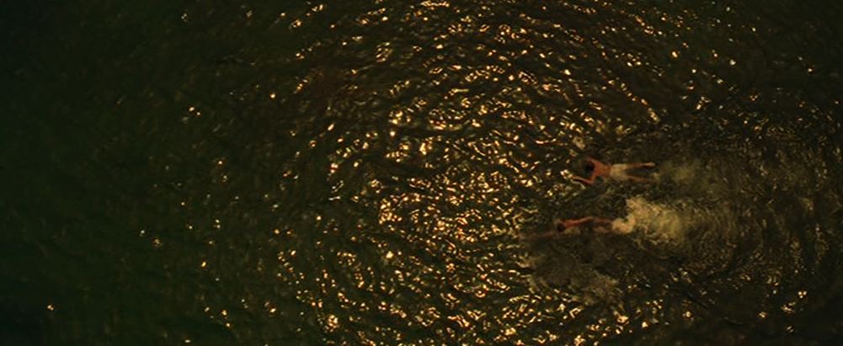 | - Overhead double-shot to show the boys side-by-side in their swim – again, echoing the earlier race  - Lighting suggests that Vincent is coming out of the shadows in to the light (metaphorically out of his brother’s shadow)  - Voiceover: ‘ Something was very different about that day…’
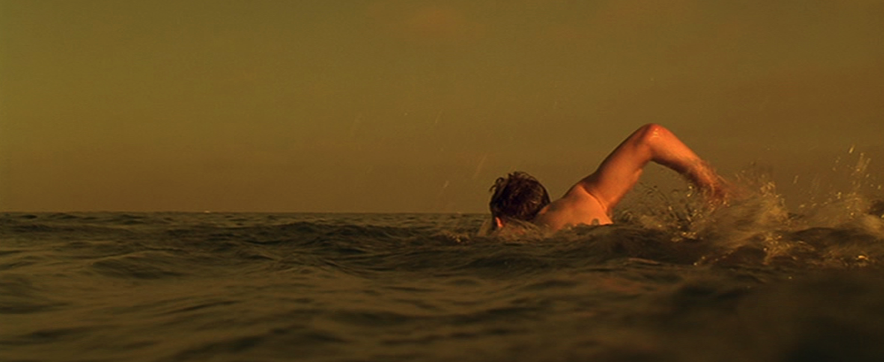 | - Point-of-view shot from Anoton’s perspective showing Vincent pull away – mirrors earlier race  - Sunlight shining down on Vincent emphasising his ‘heroic’ feat  - Voiceover continued: ‘Everytime Anoton tried to pull away, he found me right beside him until finally the impossible happened.’
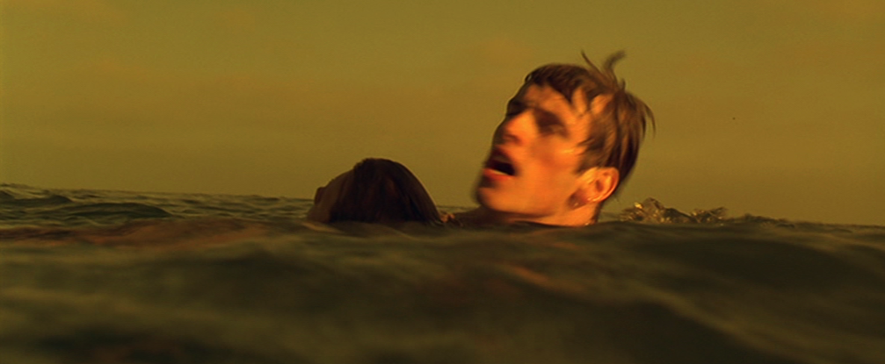 | - Close-up of Vincent saving Anton from drowning – his triumphant moment as he ‘beats’ his brother for the first time in their lives  - Voiceover continued: ‘It was the one moment in our lives that my brother was not as strong as he believed, and I was not as weak. It was the moment that made everything else possible!’
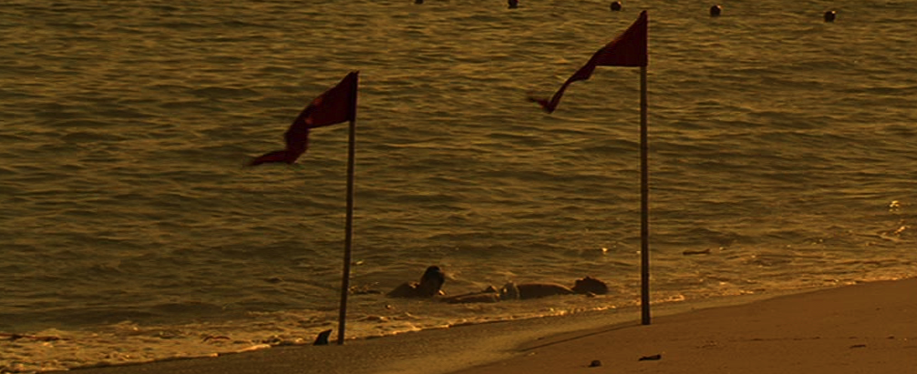 | - Long-shot of both brothers washed up on the shore  - Sound of waves lapping the shore – more peaceful than earlier to suggest the calmness now in Vincent’s life  - Darker lighting suggesting a new beginning for Vincent and Anton
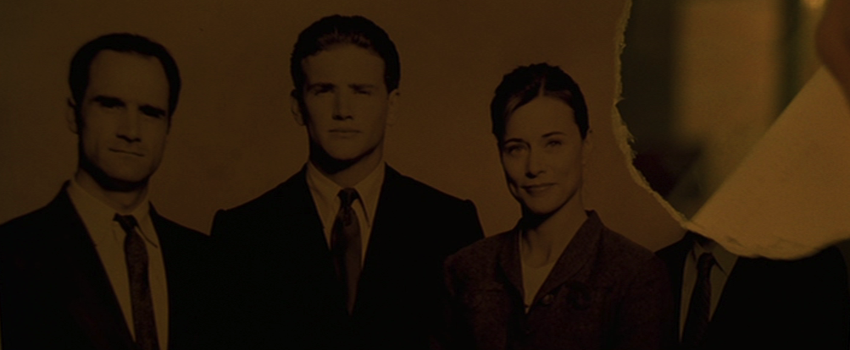 | - Cuts to an extreme close-up of family photograph indicating another shift in time  - Vincent tears his own face from family photograph – suggests he has now disowned them as they had to him  - Lighting is now very dark as it is at night – hiding away in shadows

